Homework # 4

Ruchi Panwar (rpanwar@kent.edu)

Advance Database

Fall 2015

Professor: Dr. Gregory S DeLozier

Sept 29, 2015

**Todo App With Edit & Delete Function (Using Python & PythonAnywhere)**

1. Todo app using **Visual Studio code**

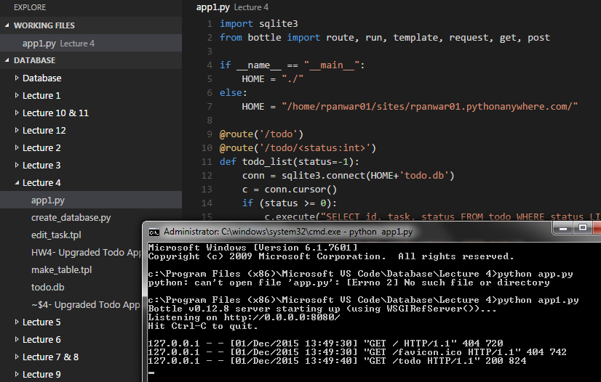

1. Code can be found on the below Github links (Lecture 4 & 5)

<https://github.com/rpanwar01/Database/tree/master/Lecture%204>

<https://github.com/rpanwar01/Database/tree/master/Lecture%205/Todo_Example>

1. List View of Todo App

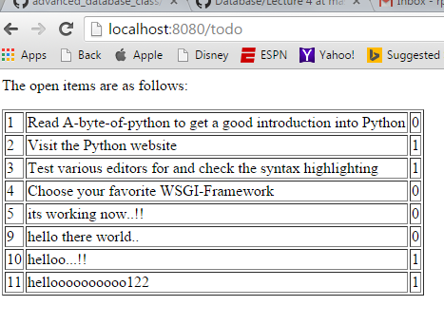

1. Add new item to the list View

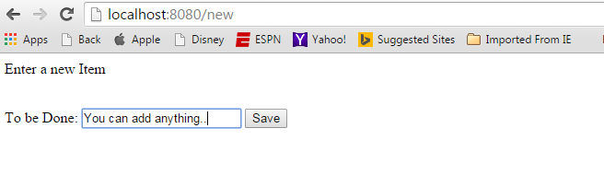

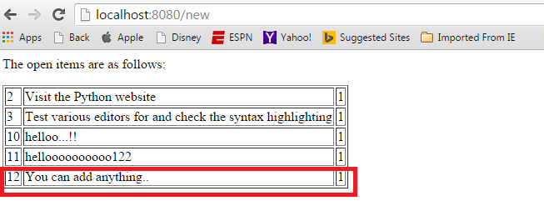

1. Edit View : edit using the item id

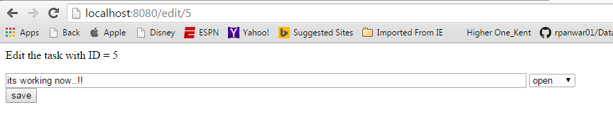

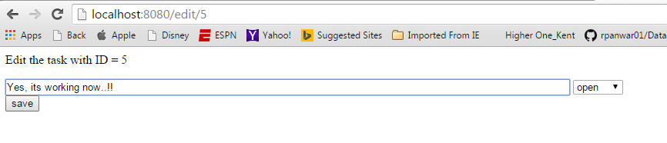

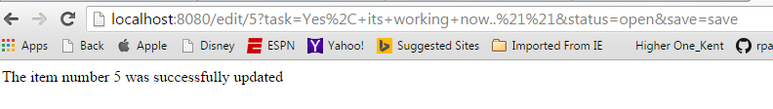

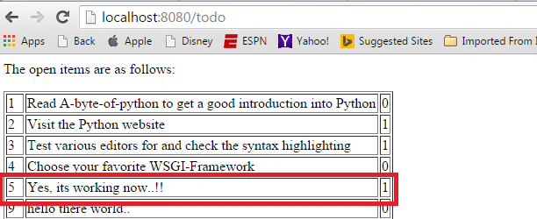

1. Delete View :delete using the item id

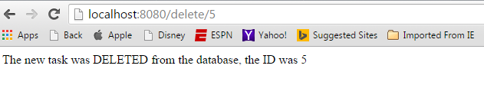

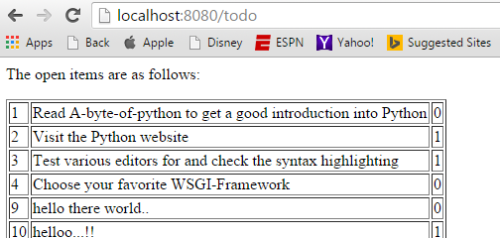

1. Todo program using **PythonAnywhere**

List View of Todo app

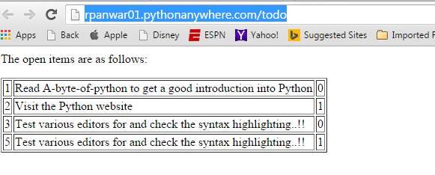

1. Add new item to the list View

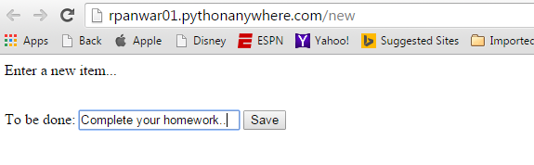

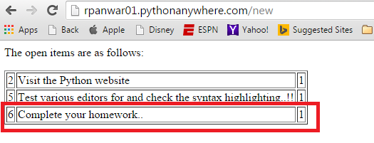

1. Edit View : edit using the item id

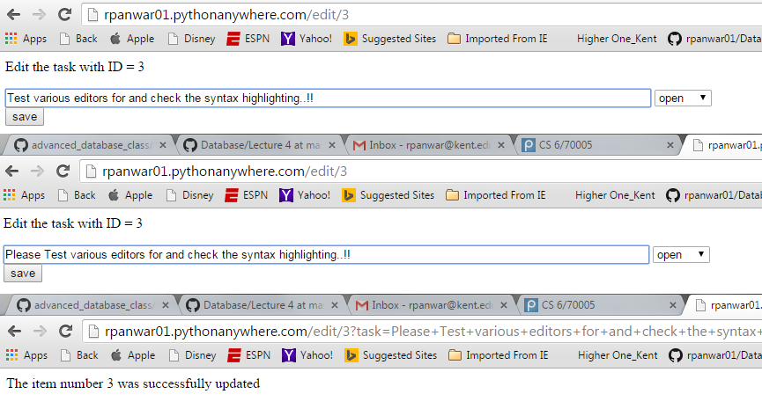

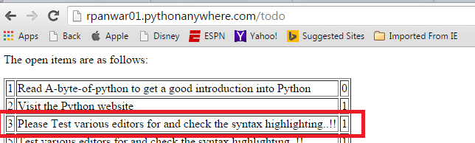

1. Delete View : Delete using the item id

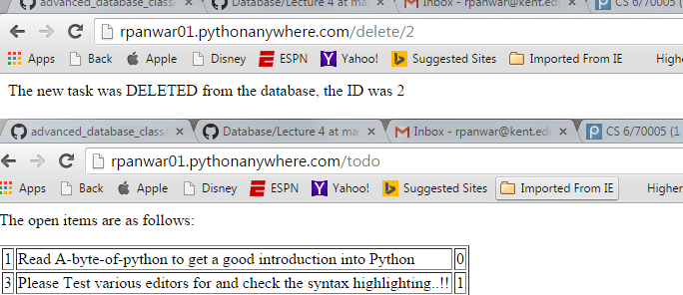

**Beautification of ToDo app - Lecture 5**

**#1 main page of the app** : http://localhost:8080/

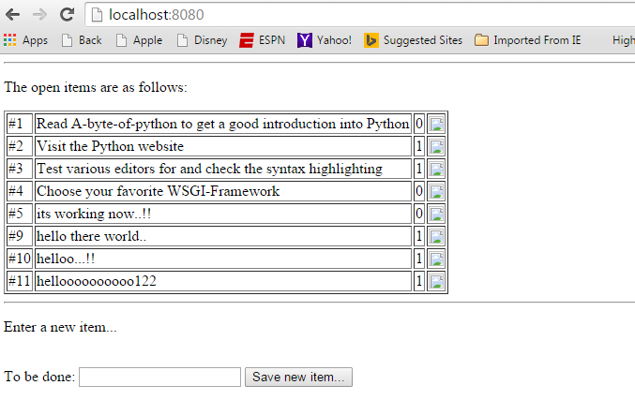

**#2 Enter a new item** -> Save new item..

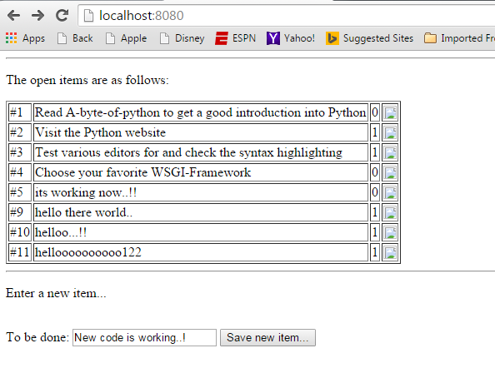

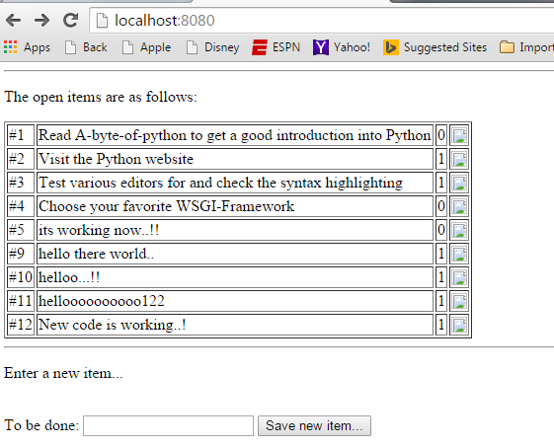

**#3 Delete an item** (in this case item 9) -> Confirm deletion..

